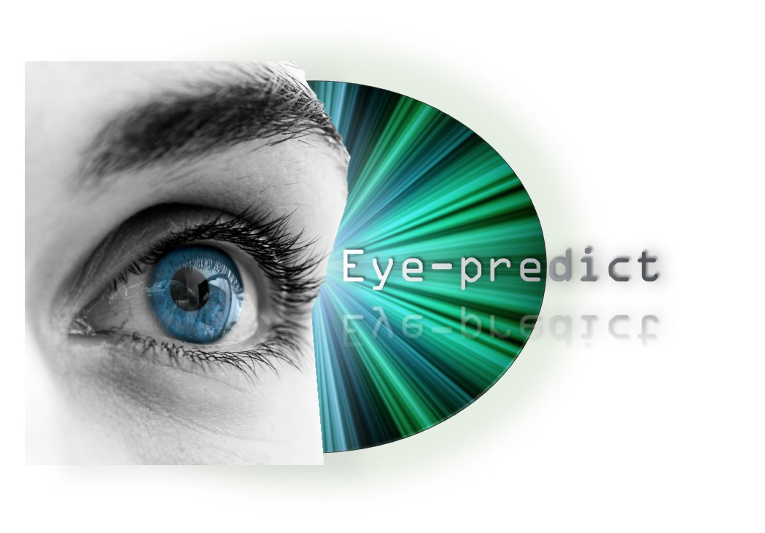

Eye-predict Version 1

USER MANUAL

Authors

Noy Shani 204690945  
Roee Malis 203854534  
Tomer Ben-David 201606787

Table of Contents

Introduction ............................................................................................................................... 3  
Installation instructions ............................................................................................................ 3  
Preparations .............................................................................................................................. 4  
Data visualization ................................................................................................................... 5  
Prediction ................................................................................................................................... 6  
Potential enhancements ............................................................................................................ 7

Introduction

Eye-predict is a tool to analyze and visualize eye-tracker data.

The tool supplies two visualization forms, heatmap and trace of saccades. Each one can be created using one trial of one subject looking at the screen, multiple trials for the same subject or multiple subjects during 1 or more trials.

Given a trial and a database, the tool attempts to predict the level of preference of the subject to the given picture on that trial. The tool supports 3 types of images: faces, snacks and fractals.

The tool is flexible and support future add-ons to be added by a programmer, such as new visualization forms, new kind of images, and new tags to predict upon.

Installation instructions

Prior to using Eye-predict, please install [Anaconda](https://www.continuum.io/downloads).

Alternatively, install separately the following:

1. [Python 3.6](https://www.python.org/downloads/)
2. [Pyqt5](https://www.riverbankcomputing.com/software/pyqt/download5)
3. [Scikit-learn](https://sourceforge.net/projects/scikit-learn/)
4. [Numpy](https://pypi.python.org/pypi/numpy)
5. [Matplotlib](https://matplotlib.org/users/installing.html)

**Mac** users can install these packages using Pip:

1. Install [Python 3.6](https://www.python.org/downloads/)
2. Open the command line terminal.
3. If Pip wasn't automatically installed with python, type "python3 get-pip.py".
4. Type "python3 -m pip install PackageName".  
   Replace "PackageName" with the following, one at a time:  
   pyqt5, scikit-learn, numpy, matplotlib.

* NOTE: The program isn't written yet, thus the final list of packages might change.

preparations

Before you are able to start working with Eye-Predict, it is necessary to organize your data. The Eye-Predict software relies on two databases: a. eye-tracking data captured during the experiment, b. matching behavioral any relevant data that could later be used as label for the eye-tracking data.

*Data Organization:*  
Project database should be a folder containing three different folders: one for the Eye-tracking data, one for the behavioral data and a third one for the related stimuli data.

*Data Formatting:*   
To allow proper data handling by the software, it is imperative that the data in use is saved in a predefined format.  
  
Behavioral data: should be saved in a tab-delimited csv format. Each file should contain data for only one subject, with each row representing a trail in the experiment.  
The first data column is used as subject ID, while there are no other limitations on data stored in the other columns

Eye-tracking data: currently our software supports only the "Eyelink 1000" eye-tracker device. As every eye-tracker device might have a different kind of data formatting, it is required to use a different parser for each device.  
A parser is a python object name "eyeParser" that converts the eye-tracking data from its raw form into a table with 3 columns (time, x, y).  
In order to use a custom parser, simply replace the python file named eyeParser.py with your own file.

To start working with your database of choice, click the Browse button and choose the main project directory.

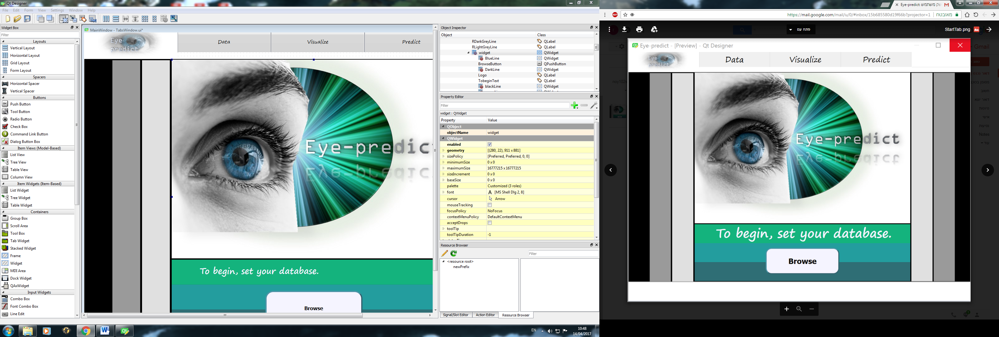

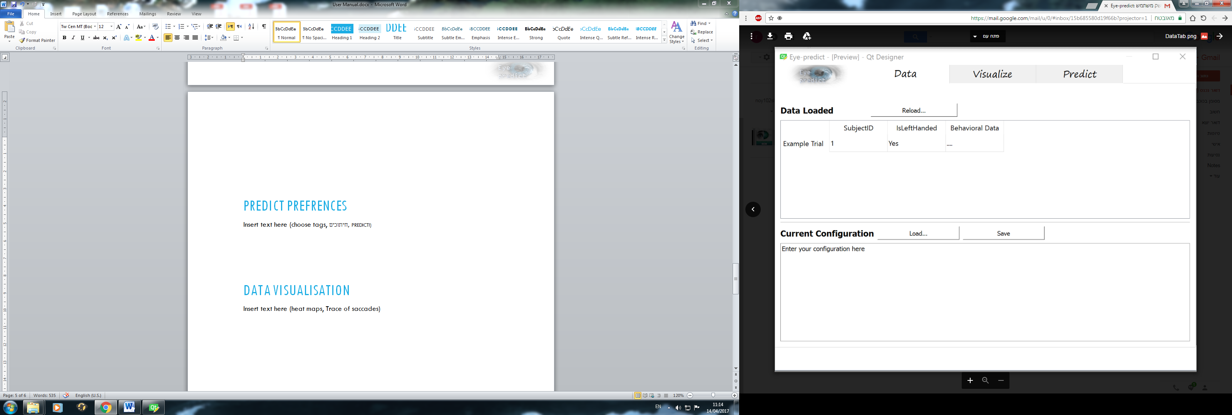After choosing your database, you will be able to view your loaded data in the corresponding Data tab. In order to make changes to your loaded data you can simply click the Reload button and choose another folder.

The configuration area is where you choose what data is important for your analysis.  
Choosing data through the configuration tells the Visualize and Predict modules what data is used for visualization or prediction.

For example, using the configuration SubjectID = 1, tells the program that the only subject data you would like to consider is that of the subject with ID of '1'.  
More explanations on how the configuration works are given in the Configuration chapter.

data visualization

The Visualize tab is where you can view eye-tarcking data using either a heatmap or the trace of saccades. While viewing your data, the currently relevant trial information is shown on the right in the Trial Info box.

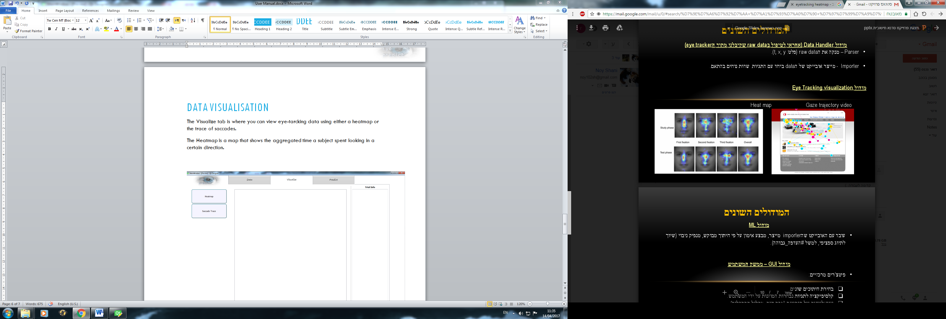The heatmap is a map that shows the aggregated time a subject spent looking in a certain direction on the screen. For example:

The heatmap feature is able to aggregate several trials' data and even several subjects' data, depending on the current configuration.  
  
The saccade trace feature is a short animation clip of a specific trial. It shows the subject's gaze position on screen during the chosen trial, while the related stimulus is shown in the background.  
You can use the Play, Pause and Rewind buttons to view the saccade trace.  
The "Save as" button allows you to save a chosen heatmap or animation for later use.

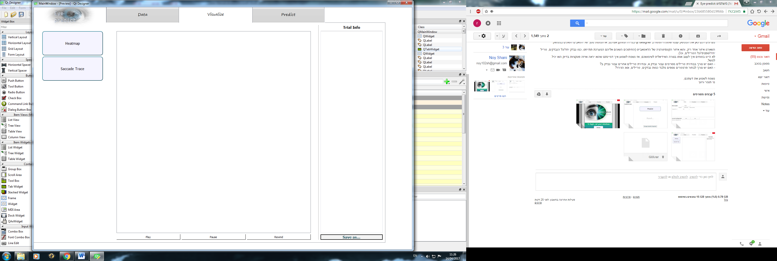

predictION

The prediction module allows you to check if any of the behavioral data is predictable by the eye-tracking data.

In order to make a prediction, you must first choose the relevant prediction label.  
Pressing the predict button will fit a classifier to your selected training data, and test it on your currently selected test data (see data selection in the Configuration chapter).

The result shown in this page is the score given to the classifier as a correct prediction percentage.

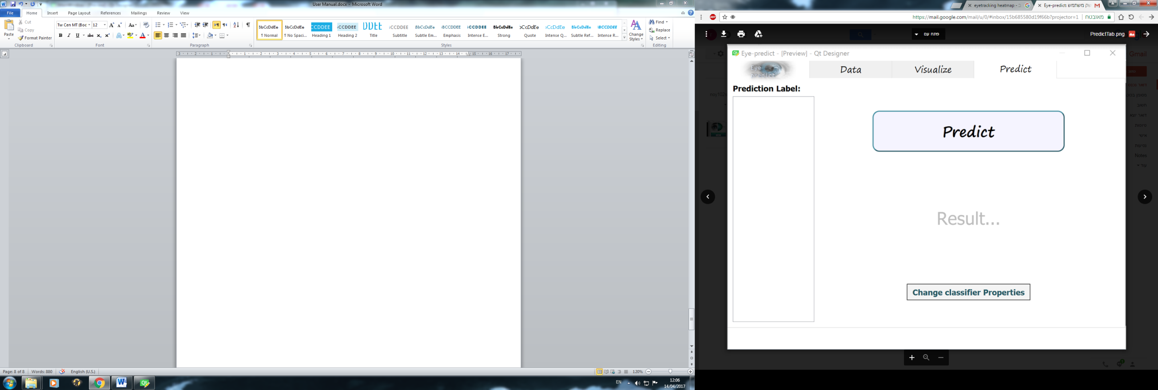

The Eye-Predict program comes with two classifiers: A stimulus type classifier, which predicts what kind of stimulus a subject was looking at (face, snack or fractal).  
The second type of classifier is the preference classifier, which predicts subject's preference for a stimulus using his eye-tracking data.

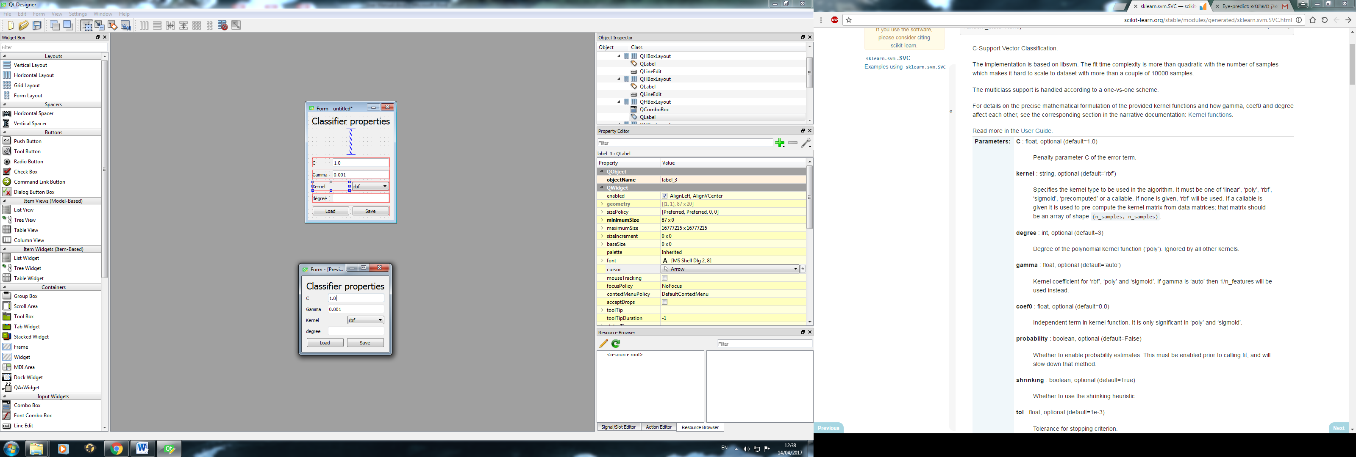The Change classifier Properties button enables you to change the settings of the current classifier or load and save a classifier preset (classifier settings are saved in a txt format).

Potential enhancements

Insert text here (future add-ons the lab/we will implement)